Team Immigration

Sprint Zero Report

1. Response to Brief

1.1 Project goals

The main objective of this Immigration project that proposed to Queensland State Archives (QSA) is to provide a solution that could bring the Immigration datasets to life with the aids of visualisation and other creative approaches. The solution is designed to provide target users a more flexible and portable portal in searching for particular Immigration data. We aim to increase the efficiency in data searching and also in the discovery of linkages, trends and any new uncovers between the data. This could be done by utilizing interactive infographic designs in the proposed solution.

1.2 Background information related to client and the project

Our client, Queensland State Archives (QSA) connects people with their past such as family history with readily accessible records. These records provide an increase understanding of Queensland's past. QSA records, keeps and use the corporate memory of Queensland to aid people in obtaining public records. There are 11 open datasets relating to immigrant ships with assisted passengers arriving in Queensland that have been released by the QSA. The most used datasets are Assisted immigration 1848 to 1912, Register of immigrants 1864 to 1878, and Register of immigrants Brisbane 1885 to 1917. All three of these datasets were compiled from original records in the QSA’s records collection. These datasets provide the answer to the public who are searching for their family history such as name, how and when did they arrive in Queensland. Academic researchers will benefit from the datasets by obtaining a greater understanding on the history of migration and its impact on social economic and cultural ties today. Currently, these dataset are available under the ‘historical’ category on the Queensland Government open data portal. Users are able to download and view them in a simple table visualisation format in the open data portal. They must go through the datasets to be able to find the information they need and it required time and effort.

1.3 Description of solution

This Immigration project involves three (3) out of eleven (11) available datasets and they are provided by QSA, which are, the Assisted Immigration 1848 to 1912, the Register of Immigrants 1864 to 1878, and the Register of Immigrants Brisbane 1885 to 1917. We proposed a web based solution instead of mobile application so users could access and perform searching with any computer device and mobile device, in anytime and anyplace. Data visualisation with charts, graphs and timeline will be implemented in the form of infographic to grab users’ attention and also helps them in capturing new discoveries, linkage and/ or trends that are yet to be uncovered by people.

Search tool will be implemented in order for users to perform searches. Users could provide information such as the name of the person, his/ her date of arrival, how did he/ she arrived to Queensland, name of the ship that he/ she on boarded and his/ her age. The results of the search will be further refined as more information are provided by the user. This search tool will promote a better, time saving, more efficient searching experience to the users compare to current searching method. There will be no account registration and login in this proposed solution as the datasets are meant to be accessible to the public without any charges. This also save users’ time in creating and logging into their account.

This solution is believed to be able to bring benefits to QSA’s target users, ranging from casual users who wish to search for their family background to academic researchers who desire to uncover the linkage between the data, immigration trends and new, unseen discoveries from the available datasets. As this will be a web based solution, all of the immigration data will be stored into a well designed online database for better accessibility and maintainability.

The backbone of this web based application will be developed with HTML5 with the supports of other languages, such as CSS, JavaScript and PHP. CSS will be used for enhancing the graphical user interface of the engine while JavaScript will be used for any visualisations and animations needed. Other than that, PHP will be utilized to allow the web based engine to search and retrieve the data stored in the databases. The theme of the website will be modern, professional and mature to suit QSA’s professional standard as the business unit of the Department of Science, Information Technology and Innovation.

2. Quotation

2.1 Work Breakdown and Development Costs

2.1.1 Work Breakdown

|  |  |  |  |
| --- | --- | --- | --- |
| User Story | Task | Complexity | Total |
| As an user I want to search the data by first name so that I can find the data with the respective name. | Search by first name | 2 | 5 |
| Valid search for first name | 3 |
|
|
|
|
| As an user I want to search the data by last name so that I can find the data with the respective name. | Search by last name | 2 | 5 |
| Valid search for last name | 3 |
| As an user I want to search the data by ship name so that I can find the data with the respective name. | Search by ship name | 2 | 5 |
| Valid search for ship name | 3 |
| As an user I want to search data by year so that I can find the data with the respective year. | Search by year | 2 | 5 |
| Valid search for year | 3 |
| As an user I want to search the data by age so that I can find the data with the respective age. | Search by age | 2 | 5 |
| Valid search by age | 3 |
| As an user I want to search data by applicant name so that I can find the data with the respective name. | Search by applicant name | 2 | 5 |
| Valid search by applicant name | 3 |
| As an user I want to search data by QSA Items ID so that I can find the data with the respective ID. | Search by QSA Items ID | 2 | 5 |
| Valid search by QSA Items ID | 3 |
| As an user I want to see chart representation of the data in the website so that I could see the summary of the information | Create the chart | 5 | 13 |
|
| Linking the chart with the database | 8 |
|
| As an user I want to see graph representation of the data in the website so that I could see the summary of the information | Create the graph | 5 | 13 |
|
| Linking the graph with the database | 8 |
|
| As an user I want to see timeline display of the information so that I could discover the trend of the immigration. | Create the timeline | 5 | 13 |
|
| Linking the timeline with the database | 8 |
|
| As an user I want to see the Ship log picture representation of the data in the website so that I could see the summary of the information. | Create a ship log picture | 3 | 8 |
|
| Linking the ship log picture with the database | 5 |
|
| Total | | | 82 |

|  |  |  |
| --- | --- | --- |
| Activity | Task | Total |
| Group and Client meetings | Discussing the progress of the immigration project. | 2 |

2.1.2 Cost

Total Cost

= (Average member’s standard hourly rates * Member’s hours) * (Number of weeks *   
 Number of semesters) + Additional supplementary cost1 + Ongoing subscription cost +   
 Maintenance cost

= ($20 per hours * 17 hours) * (13 weeks * 2 semesters) + $100 + $50 + $50

= 340 * 26 + 100 + 50 + 50

= 8840 + 100 + 50 + 50

= $9040

1 - Additional Supplementary Cost consists of licensing price for softwares such as Adobe Photoshop, which are optional.

Hours available

= (Contact time + Self-study time + Meeting time) * (Number of weeks * Number of   
 Semesters) * Number of members

= (5 hours + 10 hours + 2 hours) * (13 weeks * 2 semesters) * 6 members

= 17 * (26) * 6

= 2652 hour

3. Risk analysis

3.2 Risk Management Plan

|  |  |  |  |  |  |  |
| --- | --- | --- | --- | --- | --- | --- |
| **No** | **Risk** | **Outcome** | **Likelihood** | **Consequence** | **Rating** | **Proposed risk treatment actions to mitigate risks** |
| 1 | Incomplete project information or requirements (Scope) | Potentially to interrupt the development of the project and can be a project killers. | 3  (Moderate) | 3  (Significant) | 9  (Medium) | The scrum team make regular checking about the requirement and uses more than one method in conducting a fact-finding when meeting the client to get more detailed information. |
| 2 | Lack of experience (Team) | Potentially to slow down the project development | 3  (Moderate) | 3  (Significant) | 9  (Medium) | The development team with good experience and knowledge will support the team members with lack of experience and help them complete their task. |
| 3 | Conflict between scrum team members (Team) | Potentially to slow down the project development and in worst case scenario it also become a project killer. | 2  (Unlikely) | 3  (Significant) | 6  (Medium) | The scrum team members must respect each other's opinion and conduct a meetings regularly to find one permanent decision that has been agreed by all team members. |
| 4 | Inaccurate cost estimation (Cost) | Potentially to affects the project management if the scrum team overused the budget. | 2  (Unlikely) | 4  (Major) | 8  (Medium) | The scrum team members need to discuss and planning the cost estimation and prepared the budget based on the cost estimation to avoid budget’s overused. |
| 5 | Lack of consultation with client (Communication) | The scrum team will get incomplete requirement and information for the project and potentially will lead to the project failure when the project not meet the goals and satisfies the client. | 3  (Moderate) | 4  (Major) | 12  (High) | The scrum team members must always keep in touch with client and update regularly the project progress to ensure the project is based on the client requirements and needs. |
| 6 | Scrum team misunderstand requirements (Communication) | Potentially to lead to project failure when the developed project is not based on the right requirements. | 2  (Unlikely) | 4  (Major) | 8  (Medium) | When conduct the meeting between the scrum team members, the client or scrum master need to briefly explains about the project requirements and notify the scrum team members if there any change occurs in the project during each meeting. |
| 7 | Failure to follow the project methodology (Management) | Potentially to slow down the project. | 2  (Unlikely) | 2  (Minor) | 4  (Low) | The scrum team members must always communicating with the lectures to get more information about the methodology used for the project which is scrum/sprint method. |
| 8 | Problems and issues on project management tools (Technical) | Potentially to slow down the project and | 2  (Unlikely) | 2  (Minor) | 4  (Low) | The scrum team members need to discuss and make a planning what tools will be used in developing the project and make sure the scrum team members know how to use the tools. For example using the Microsoft Office Project to design the gantt chart. |
| 9 | Database failure (Technical) | It will give the big impact on the project when the data cannot be retrieved from the database. | 3  (Moderate) | 4  (Major) | 12  (High) | The scrum team members need to do proper planning for the whole database to ensure the database works well when the database were linked to the system. |
|  | Failed to retrieve related search results from the database | No searches can be done until the problem is determined and solved | 3  (Moderate) | 3  (Significant) | 8  (Medium) | Perform error checking and testing on the related coding until the data can be successfully retrieved |
|  | Infographic failed to display accurate information | Researchers failed to obtain accurate data for their researches. | 3  (Moderate) | 3  (Significant) | 8  (Medium) | Perform error checking and testing on the related coding until the data can be accurately displayed |
|  | Databased is modified by unauthorized party | Breach of trust to QSA’s reliability | 2  (Unlikely) | 4  (Major) | 12  (High) | Only authorized party from QSA are provided with the password for access to the database. Changes to the database need to be confirmed by another authorized person/ administrator. |

4. Sprint Cycle

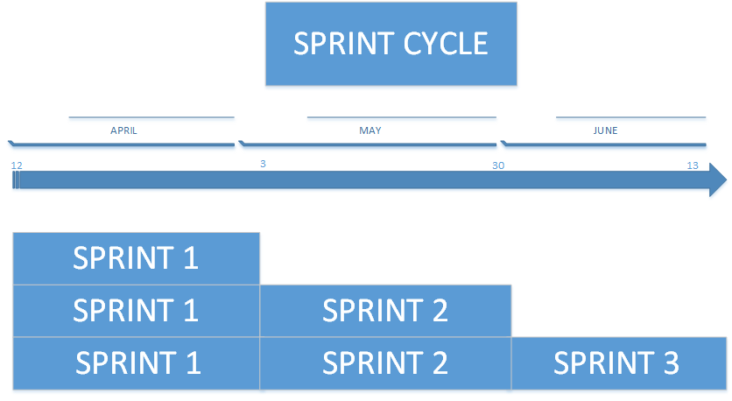

*Figure 4.1 — Sprint Cycle*

|  |  |  |
| --- | --- | --- |
| DATE | ACTIVITY | DEADLINE |
| 12 APRIL 2016 | SPRINT MEETING ZERO | Pitch/Quote/Early Prototype |
| 3 MAY 2016 | SPRINT MEETING ONE | Early Proposal | Critique from Client |
| 30 MAY 2016 | SPRINT MEETING TWO | Project Proposal Presentation |
| 13 JUNE 2016 | SPRINT MEETING THREE | Project Proposal |

5. Product Backlog

|  |  |  |
| --- | --- | --- |
| USER STORY | BUSINESS PRIORITY | STORY POINT |
| As an user I want to search the data with first name so that I can find the information | 1 | 5 |
| As an user I want to search the data LAST name so that I can find the information based on the data I know | 1 | 5 |
| As an user I want to search the data age so that I can find information based on the data I know | 2 | 5 |
| As an user I want to search the data date so that I can find the information based on the data I know | 2 | 5 |
| As an user I want to search the data ship name so that I can find the information based on the data I know | 3 | 5 |
| As an user I want to search the data QSA Items ID so that I can find the information based on the data I know | 3 | 5 |
| As an user I want to search the data applicant name so that I can find the information based on the data I know | 3 | 5 |
| As an user I want to see the timeline representation of data in the website so that I can see the detail of information more interactively | 4 | 13 |
| As an user I want to see the graph representation of data in the website so that I can see the detail of information more interactively | 5 | 13 |
| As an user I want to view the chart representation of data in the website so that I can see the summary about the data in interactive way | 5 | 13 |
| As an user I want to see the Ship log picture so that I can see the information more visually | 6 | 8 |

6. Research Results

6.1 Data Visualisation

Data visualization is the process of helping users understand the importance in any data by putting it in a visual context.xt. (Rouse, data visualization, 2012) It is easier for patterns, trends, and new discoveries to be exposed if data visualization is used compared to the current text based data in a basic spreadsheet format of the Immigration data. Example of good data visualization is shown below:

* Easy to understand
* Attractive
* Not confusing
* Interactive
* Same scales
* Display data by appropriate graphics

Visual perception is easier and faster than cognition. Thus, due to this way of how humans processes data, users does not only process patterns, linkage and trends faster but easier as well. (SAS, n.d.) Data visualisation does not only meant static and non interactive images. Interactive capabilities can be implemented to allow manipulation of data by users. (Rouse, data visualization, 2012)

6.2 Infographics

Infographics is the usage of visual images such as charts, diagrams, and timeline to represent data.(Rouse, infographics, 2012) Infographics allows users to easily understand data at a glance. Since the Immigration data is in a large amount and is tabulated according to attributes, it is easier to use infographics to communicate a message quickly and allow users to see data relationships and patterns.

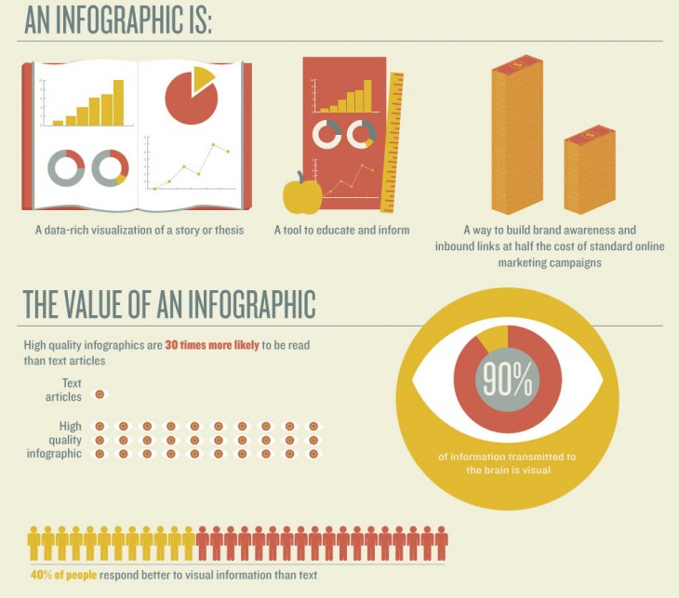

*Figure 6.2.1: Definition of Infographic. Retrieve from:*

*Futterman, E. (2014). 10 ways to use infographics.*

6.3 Wireframe/Mockups

Interactive Version Link: <https://marvelapp.com/1g758d7>

UQCloud Link: <http://deco3800-immi.uqcloud.net>

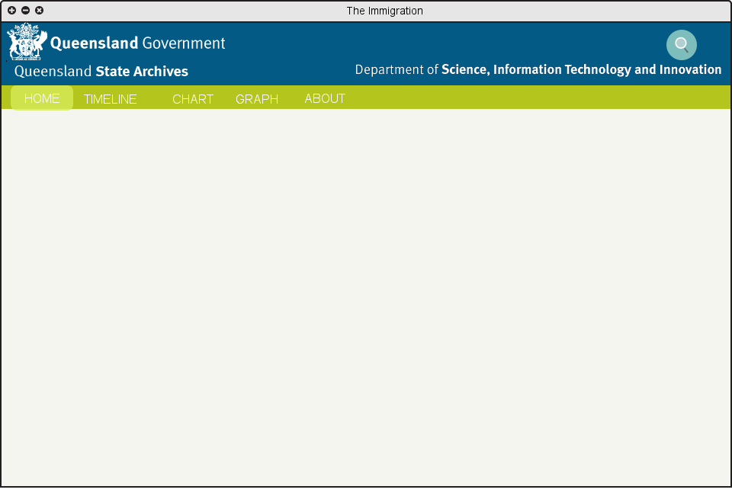

*Figure 6.3.1 — Main Page*

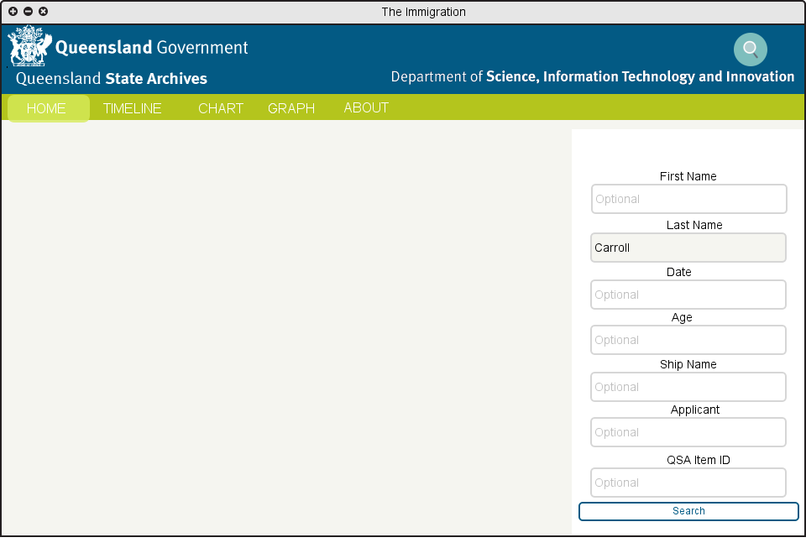

*Figure 6.3.2a — Search Tool (Search by Last Name)*

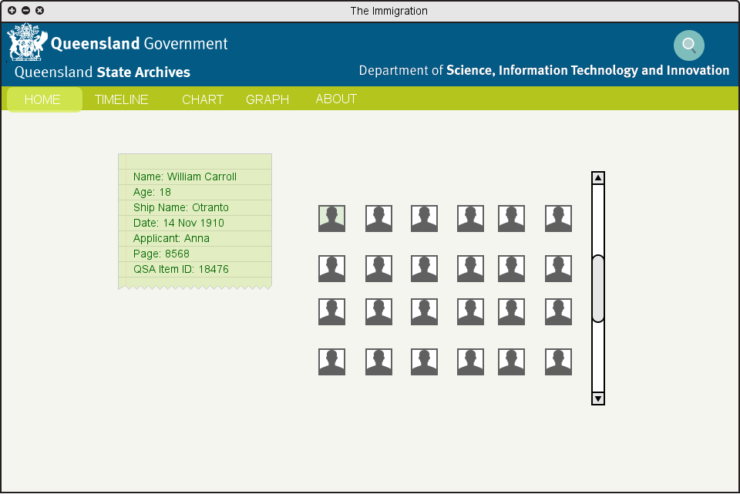

*Figure 6.3.2b — Results Page (Search by Last Name)*

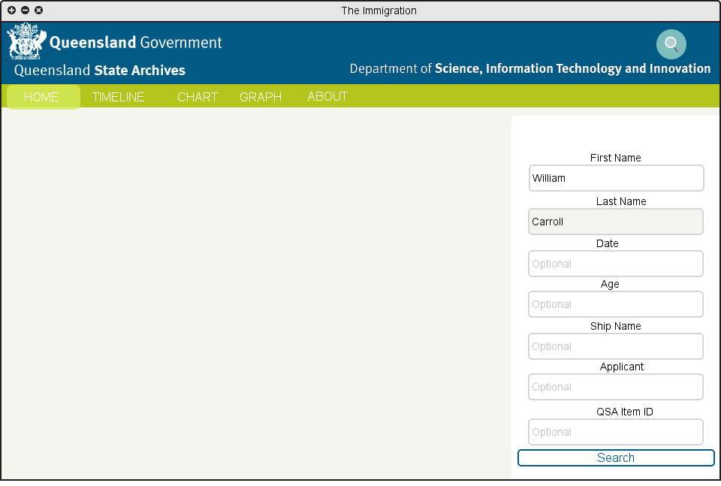

*Figure 6.3.3a — Search Function (Search by First Name)*

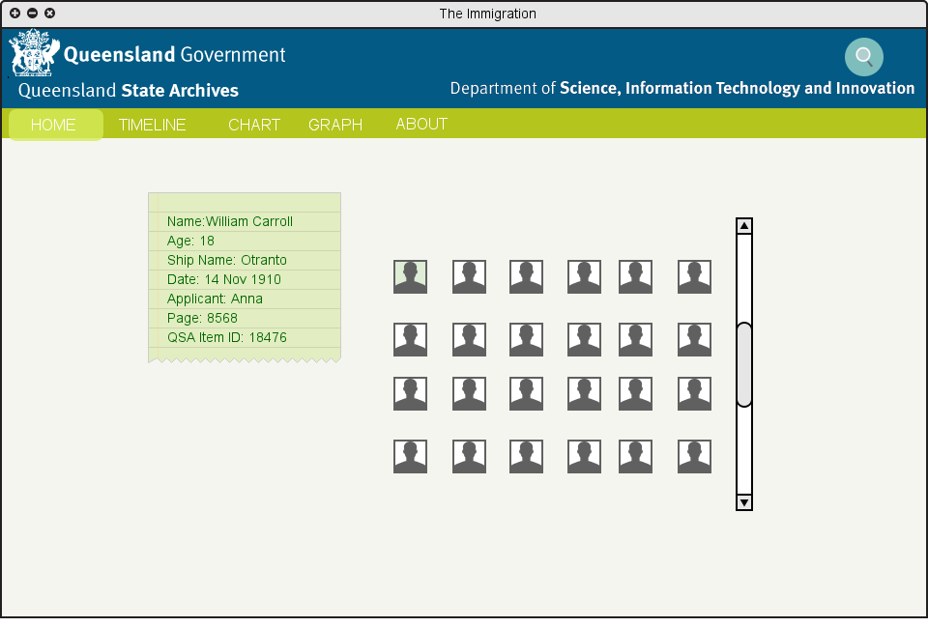

*Figure 6.3.3b — Results Page (Search by First Name)*

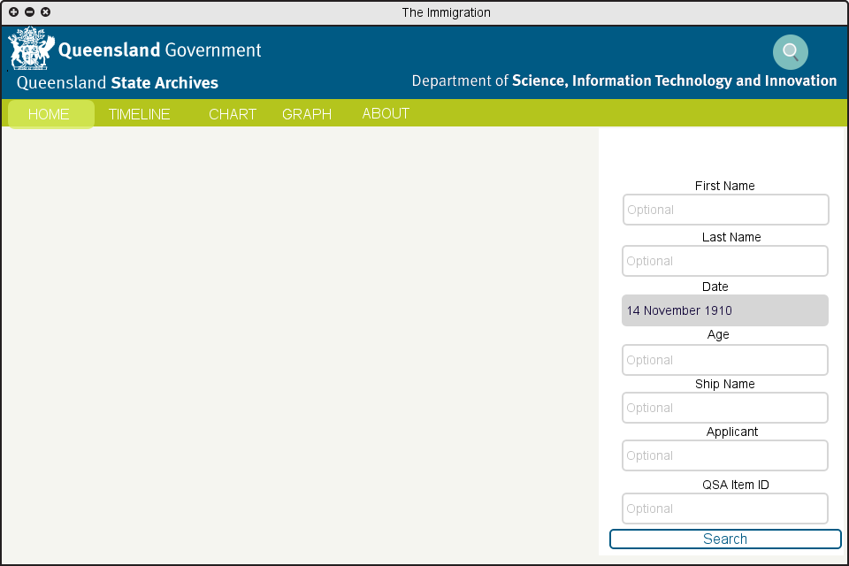

*Figure 6.3.4a — Search Function (Search by Date)*

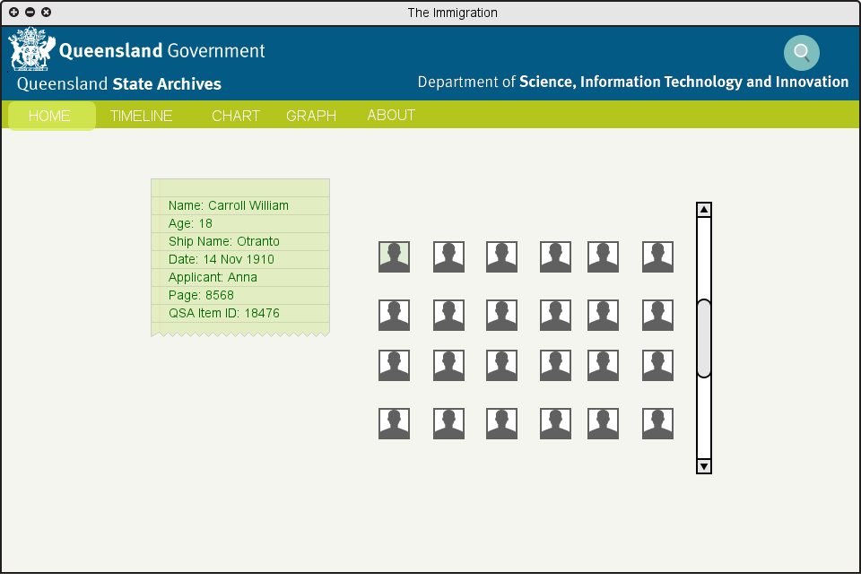

*Figure 6.3.4b — Results Page (Search by Date)*

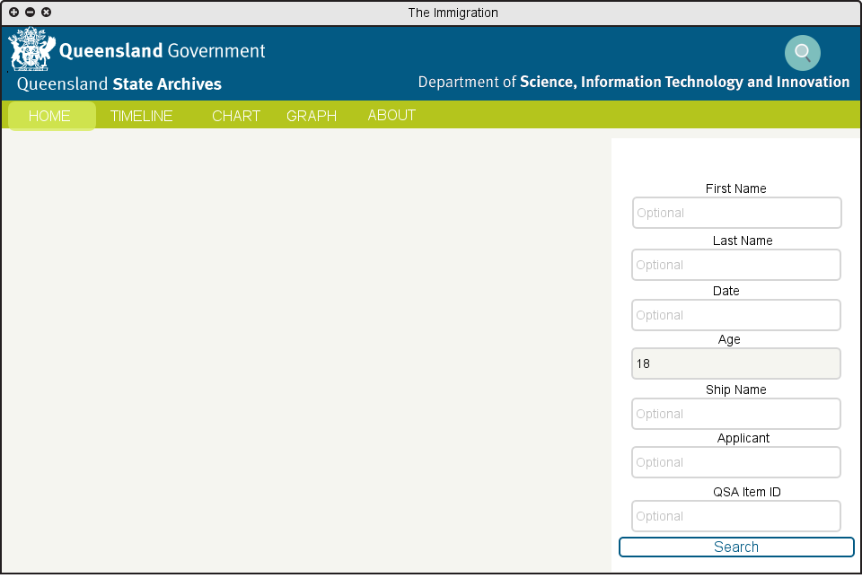

*6.3.5a — Search Function (Search by Age)*



*6.3.5b — Results Page(Search by Age)*

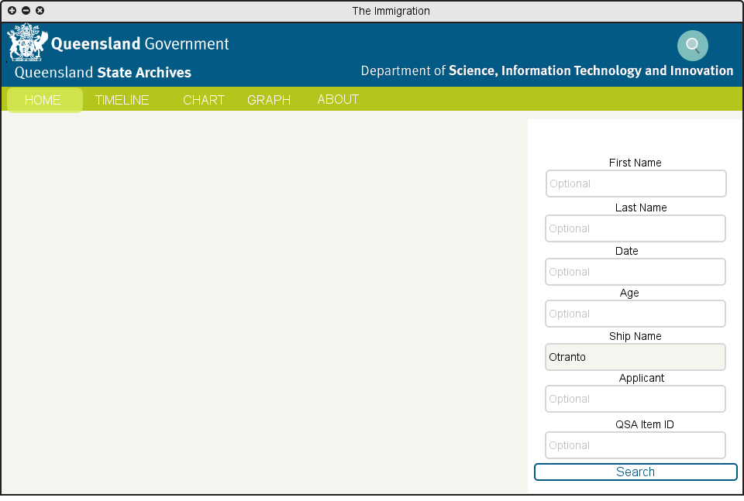

*Figure 6.3.6a — Search Function (Search by Ship Name)*

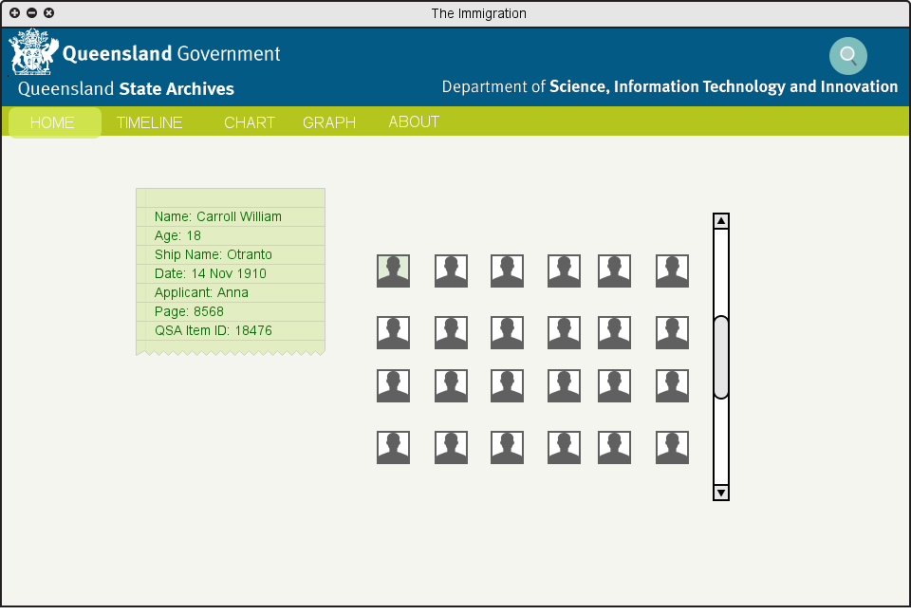

*Figure 6.3.6b — Results Page (Search by Ship Name)*

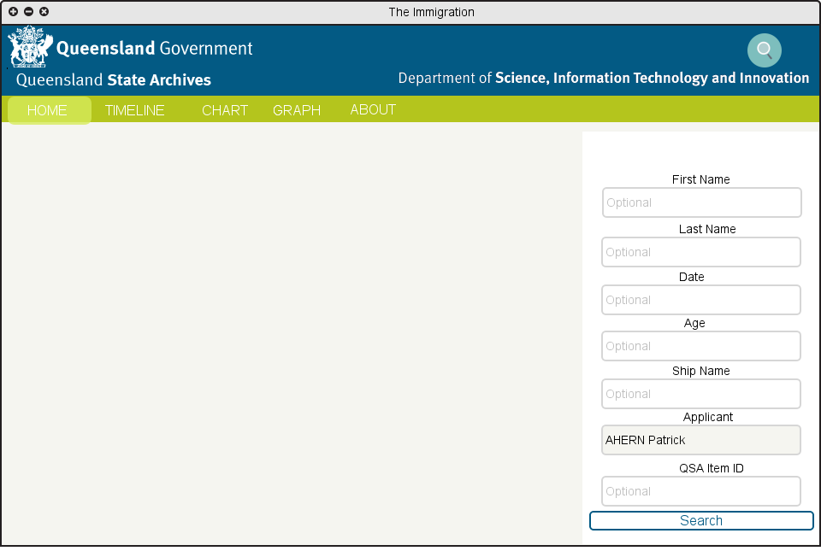

*Figure 6.3.7a — Search Function (Search by Applicant)*

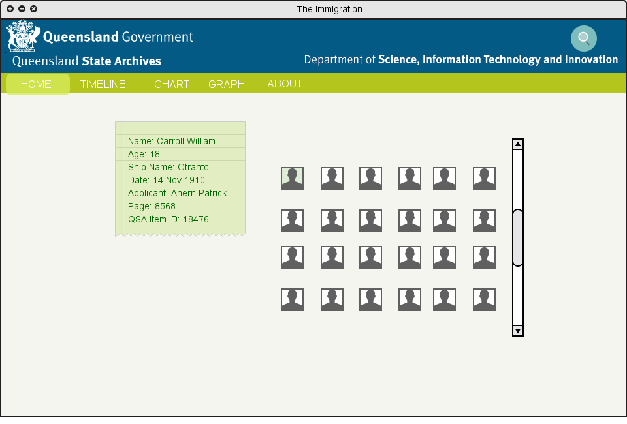

*Figure 6.3.7b — Results Page (Search by Applicant)*

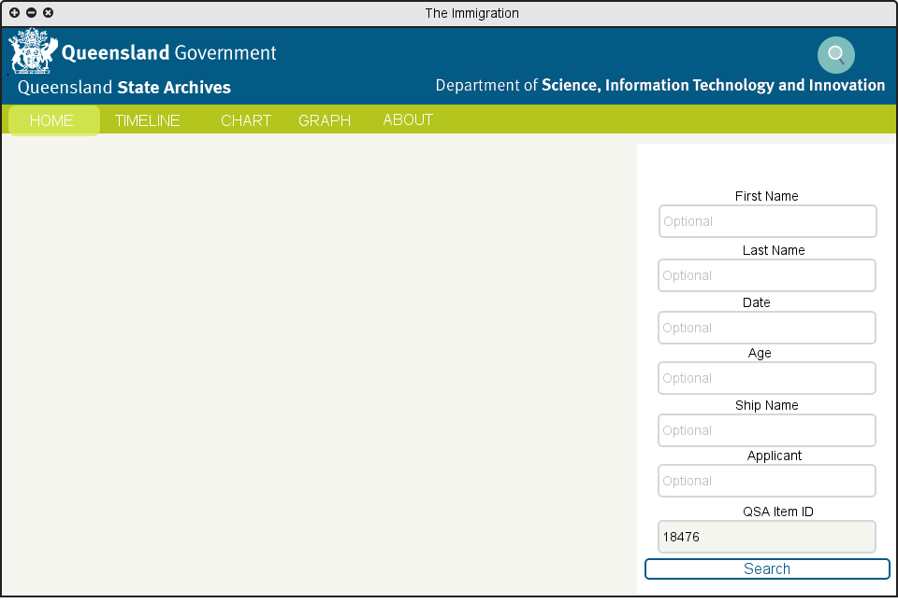

*Figure 6.3.8a — Search Function (Search by QSA Item ID)*

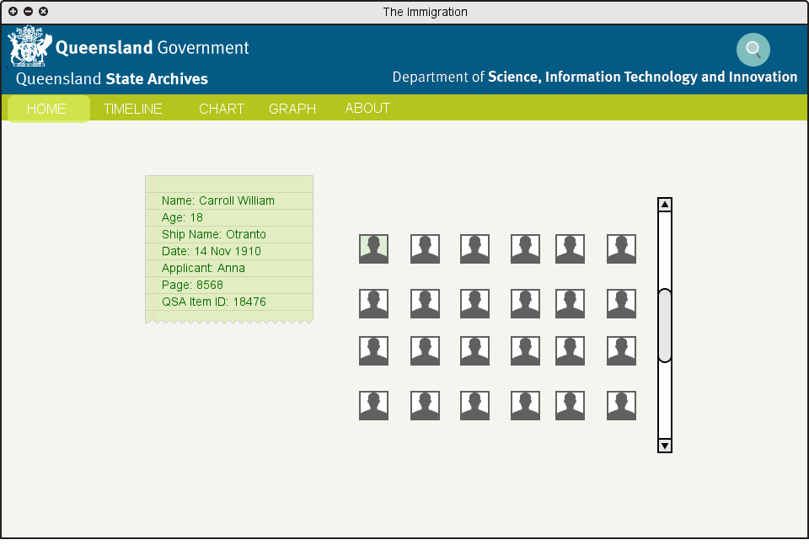

*Figure 6.3.8b — Results Page (Search QSA Item ID)*

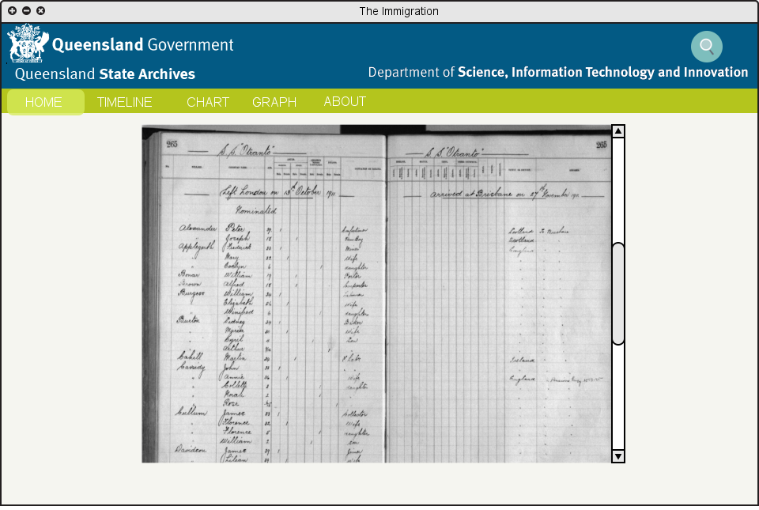

*Figure 6.3.9 — Ship Log Picture Page (By Clicking on Men Icon)*

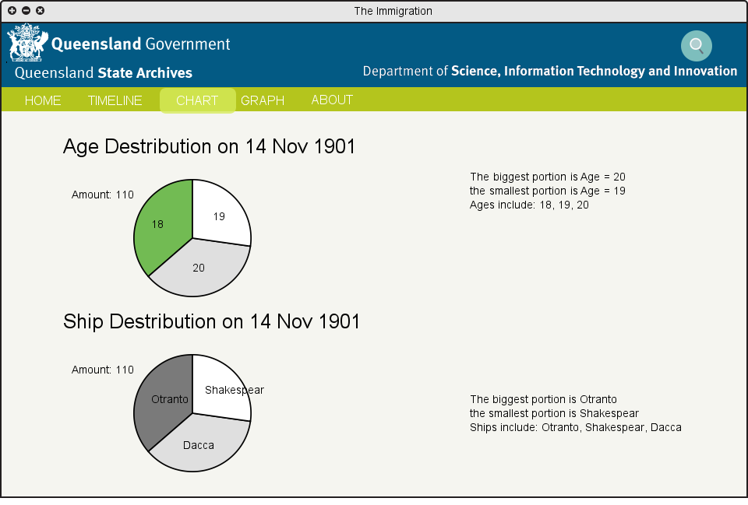

*Figure 6.3.10 — Chart Page*

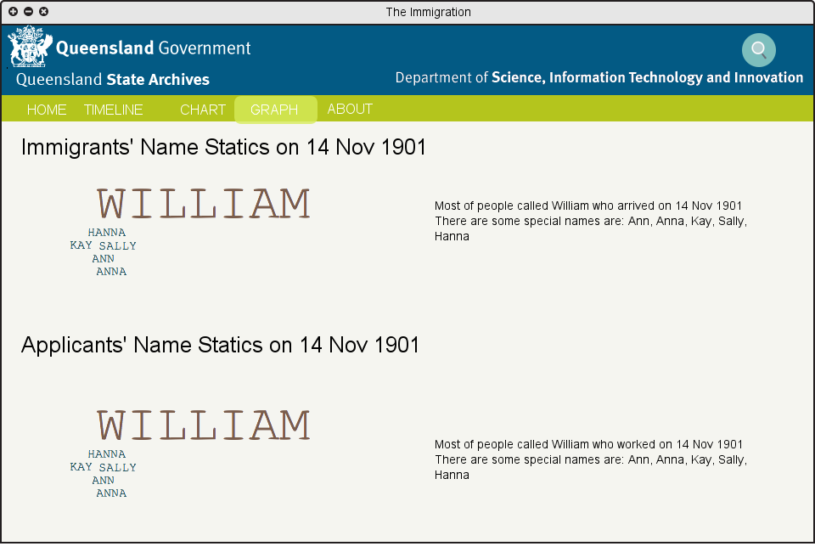

*Figure 6.3.11 — Graph Page*

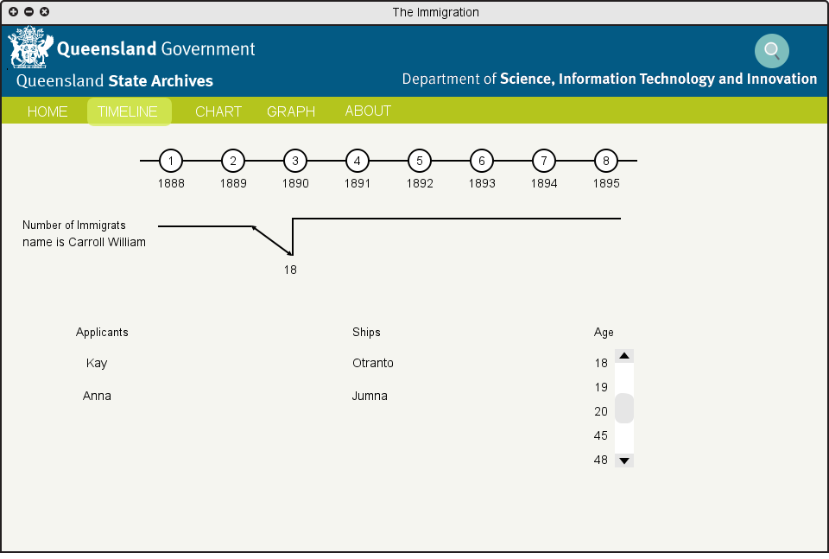

*Figure 6.3.12 — Timeline Page*

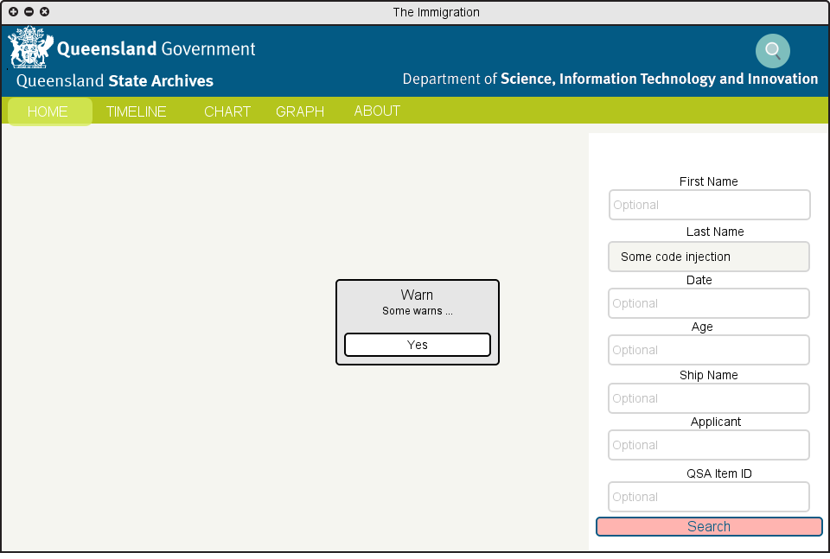

*Figure 6.3.13 — Notification (Display Error Message)*

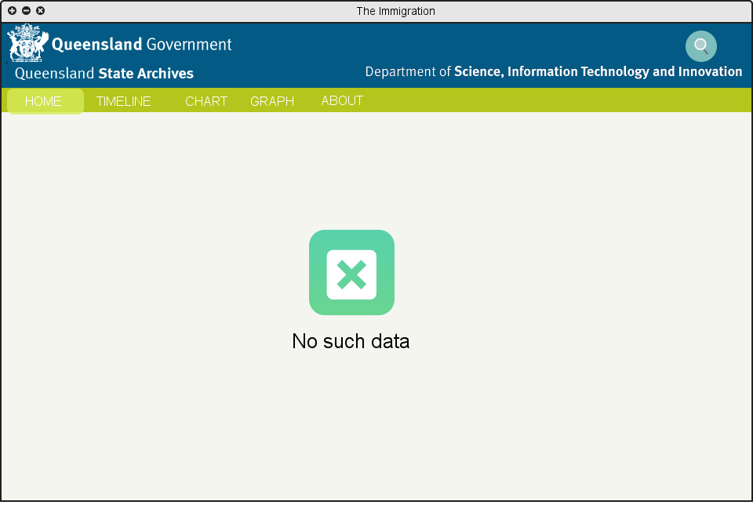

*Figure 6.3.14 — Results Page (No Results Return)*

6.4 Search Progress

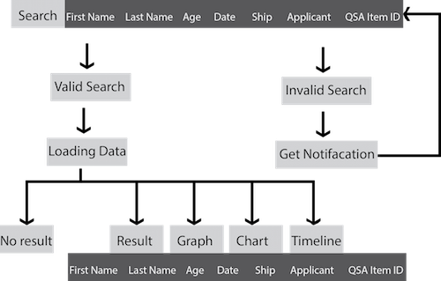

*Figure 6.4.1 — Data Searching Flow*

# 

# 

# 

# 

# 

# 

# 

# 

References

Futterman, E. (2014). *10 ways to use infographics*. Retrieved 8 March, 2016, from The Next Web Website: http://thenextweb.com/dd/2013/10/16/10-ways-use-infographics/#gref

Rouse, M. (May, 2012). *data visualization*. Retrieved 8 March, 2016, from TechTarget Web site: http://searchbusinessanalytics.techtarget.com/definition/data-visualization

Rouse, M. (February, 2012). *infographics*. Retrieved 8 March, 2016, from whatis: http://whatis.techtarget.com/definition/infographics

SAS. (n.d.). *Data Visualization: What it is and why it matters*. Retrieved 8 March, 2016, from SAS Website: http://www.sas.com/en_us/insights/big-data/data-visualization.html